**CNN-Based Strategies for Early Detection and Prevention of Plant Diseases**

Rama Sai Surya Teja Monavarthy , Srikanth Narisetti, Dimple Greeshma Devatha,Varsha Thatikonda

***Abstract: The agricultural sector faces significant challenges in ensuring global food security, exacerbated by the increasing prevalence of plant diseases. Timely detection and prevention of these diseases are crucial to safeguarding crop yields and maintaining food production. In recent years, Convolutional Neural Network (CNN)-based strategies have emerged as powerful tools for early detection and prevention of plant diseases. This paper provides a comprehensive overview of CNN-based approaches utilized in the agricultural domain, focusing on their application in the early detection and prevention of plant diseases.***

***CNNs have shown remarkable success in image classification tasks, leveraging their ability to automatically learn hierarchical representations from raw pixel data. In the context of plant disease detection, CNNs are trained on large datasets comprising images of healthy and diseased plants, enabling them to recognize subtle visual cues indicative of various diseases. Through the process of feature extraction and classification, CNNs can accurately identify plant diseases with high precision and recall rates.***

***One of the key advantages of CNN-based strategies is their ability to handle complex and heterogeneous datasets, encompassing a wide range of plant species and disease types. Transfer learning, a technique whereby pre-trained CNN models are fine-tuned on domain-specific data, has proven particularly effective in addressing the challenges of limited annotated datasets and domain-specific variations. By leveraging knowledge learned from large-scale datasets such as ImageNet, transfer learning enables CNNs to achieve superior performance even with limited training data, thereby facilitating the development of robust disease detection systems.***

***Furthermore, CNN-based approaches offer scalability and cost-effectiveness, making them well-suited for deployment in real-world agricultural settings. With the proliferation of low-cost imaging devices such as smartphones and drones, farmers can readily capture high-resolution images of their crops, which can then be analyzed using CNN-based algorithms deployed on edge devices or cloud platforms. This enables early detection of plant diseases directly in the field, empowering farmers to take proactive measures to mitigate crop losses and minimize the spread of diseases.***

***In addition to disease detection, CNNs can also play a pivotal role in disease prevention through the application of precision agriculture techniques. By integrating disease prediction models with decision support systems, farmers can optimize resource allocation, such as water, fertilizers, and pesticides, thereby minimizing the risk of disease outbreaks and reducing environmental impact. Furthermore, CNNs can facilitate targeted intervention strategies, enabling precise application of treatments only to affected areas, thus minimizing input costs and maximizing efficiency.***

***In conclusion, CNN-based strategies offer promising avenues for early detection and prevention of plant diseases, providing farmers with valuable tools to safeguard crop health and enhance agricultural productivity. Continued research and innovation in this field are essential to further advance the capabilities of CNNs and realize their full potential in addressing the complex challenges facing modern agriculture.***

***Keywords- Convolutional Neural Networks (CNNs), Plant diseases, Early detection, Prevention, Agricultural domain, Transfer learning, Precision agriculture, Model Evaluation***

# I. INTRODUCTION

The agricultural sector serves as the backbone of global food production, supplying essential sustenance for humanity's ever-growing population. However, this vital industry faces numerous challenges, chief among them being the rampant prevalence of plant diseases. Plant diseases inflict substantial losses on crop yields annually, threatening food security and livelihoods worldwide. Timely detection and effective prevention of these diseases are imperative to mitigate their adverse impacts and ensure sustainable agricultural productivity.

In recent years, the emergence of advanced technologies, particularly in the field of artificial intelligence (AI), has provided new avenues for addressing the challenges posed by plant diseases. Among these technologies, Convolutional Neural Networks (CNNs) have garnered considerable attention for their exceptional capabilities in image analysis and pattern recognition. CNNs, a class of deep learning models inspired by the visual cortex of the human brain, have demonstrated remarkable success in a myriad of tasks, including image classification, object detection, and segmentation.

The application of CNNs in the agricultural domain, particularly for the early detection and prevention of plant diseases, holds immense promise. Traditional methods of disease diagnosis often rely on visual inspection by trained agronomists, which can be time-consuming, labor-intensive, and prone to human error. Moreover, these methods may not always yield accurate results, especially in the case of subtle or latent symptoms of diseases.

In contrast, CNN-based approaches offer a revolutionary paradigm shift in disease detection and prevention, leveraging the power of machine learning to analyze vast amounts of visual data with unprecedented accuracy and efficiency. By training CNNs on large datasets comprising images of healthy and diseased plants, these models can learn to recognize subtle patterns and features indicative of various diseases. Through the process of feature extraction and classification, CNNs can distinguish between healthy and infected plants with high precision, enabling early detection of diseases before they inflict irreparable damage.

One of the primary advantages of CNN-based strategies lies in their ability to handle complex and heterogeneous datasets encompassing a wide range of plant species and disease types. Transfer learning, a technique whereby pre-trained CNN models are fine-tuned on domain-specific data, has emerged as a powerful tool to address the challenges of limited annotated datasets and domain-specific variations. By leveraging knowledge learned from large-scale datasets such as ImageNet, transfer learning enables CNNs to achieve superior performance even with limited training data, thus facilitating the development of robust disease detection systems.

Furthermore, the scalability and cost-effectiveness of CNN-based approaches make them well-suited for deployment in real-world agricultural settings. With the proliferation of low-cost imaging devices such as smartphones and drones, farmers can readily capture high-resolution images of their crops, which can then be analyzed using CNN-based algorithms deployed on edge devices or cloud platforms. This enables early detection of plant diseases directly in the field, empowering farmers to take proactive measures to mitigate crop losses and minimize the spread of diseases.

In addition to disease detection, CNNs can also play a pivotal role in disease prevention through the application of precision agriculture techniques. By integrating disease prediction models with decision support systems, farmers can optimize resource allocation, such as water, fertilizers, and pesticides, thereby minimizing the risk of disease outbreaks and reducing environmental impact. Furthermore, CNNs can facilitate targeted intervention strategies, enabling precise application of treatments only to affected areas, thus minimizing input costs and maximizing efficiency.

In conclusion, the application of CNN-based strategies for the early detection and prevention of plant diseases represents a significant advancement in modern agriculture. By harnessing the power of AI and machine learning, these approaches offer farmers invaluable tools to safeguard crop health, enhance productivity, and ensure food security for future generations. However, challenges remain in terms of data availability, model interpretability, and scalability, necessitating continued research and innovation in this field to fully realize its potential. Through interdisciplinary collaboration and technological innovation, we can leverage CNNs to address the complex challenges facing global agriculture and pave the way towards a more sustainable and resilient food system.

# II. Motivation

The motivation behind the research on CNN-based strategies for early detection and prevention of plant diseases stems from the urgent need to address the profound impact of plant diseases on agricultural productivity, food security, and economic stability. Despite significant advancements in agricultural practices and technologies, plant diseases continue to pose formidable challenges to farmers worldwide. These diseases can lead to substantial yield losses, affecting both smallholder farmers in developing countries and large-scale agricultural operations in industrialized nations. One of the primary motivations for employing CNN-based approaches is the inefficiency and limitations of traditional disease detection methods. Conventional techniques such as visual inspection by human experts are often subjective, time-consuming, and prone to errors. Furthermore, the rapid spread of diseases in today's interconnected world necessitates a proactive and timely response, which may not be feasible with manual inspection alone. CNNs offer a promising alternative by automating the process of disease detection and enabling rapid analysis of large-scale agricultural datasets. Moreover, the increasing demand for sustainable agriculture and environmentally friendly practices underscores the importance of early disease detection and targeted intervention. By accurately identifying diseased plants at an early stage, farmers can implement precision agriculture techniques to minimize the use of agrochemicals, reduce environmental pollution, and optimize resource allocation. CNN-based models provide the necessary tools to implement these strategies effectively, enabling farmers to make informed decisions based on real-time data and actionable insights. Another key motivation for research in this area is the potential socio-economic impact of plant diseases on global food security and livelihoods. With the world's population projected to exceed 9 billion by 2050, the pressure to sustainably increase agricultural productivity has never been greater. Plant diseases threaten to undermine these efforts by destabilizing food production systems, exacerbating poverty, and contributing to food insecurity in vulnerable communities. By developing robust CNN-based solutions for disease detection and prevention, we can help mitigate these risks and build resilience in agricultural systems worldwide. The motivation for research on CNN-based strategies for early detection and prevention of plant diseases is driven by the pressing need to address the complex challenges facing global agriculture. By harnessing the power of AI and machine learning, we can revolutionize disease management practices, empower farmers with innovative tools, and pave the way towards a more sustainable and resilient food system for future generations.

III. Main Contributions & Objectives

1. Develop and optimize CNN-based algorithms for the early detection of plant diseases using image analysis techniques.

2. Create a comprehensive dataset comprising high-quality images of healthy and diseased plants across multiple crop species and disease types.

3. Investigate the effectiveness of transfer learning in adapting pre-trained CNN models to the domain of plant disease detection.

4. Explore the integration of CNN-based disease detection systems with low-cost imaging devices such as smartphones and drones for on-field implementation.

5. Evaluate the performance of CNN-based models in terms of accuracy, precision, recall, and computational efficiency under varying environmental conditions and disease severities.

6. Investigate the scalability and feasibility of deploying CNN-based disease detection systems in real-world agricultural settings, considering factors such as data transmission, processing speed, and resource requirements.

7. Develop decision support systems that leverage CNN-based disease detection models to provide actionable insights for farmers, enabling targeted interventions and resource optimization.

8. Assess the socio-economic impact of implementing CNN-based strategies for early detection and prevention of plant diseases on agricultural productivity, food security, and environmental sustainability.

9. Collaborate with stakeholders including farmers, agricultural extension services, and technology providers to ensure the practical relevance and adoption of CNN-based solutions in diverse agricultural contexts.

# IV. Related Work

1. **"Deep Learning-Based Tomato Disease Classification Using Color and Texture Features" by Hasan et al. (2020):** This study proposed a deep learning-based approach for classifying tomato diseases using color and texture features extracted from leaf images. The authors achieved high accuracy in disease classification, demonstrating the effectiveness of deep learning techniques for plant disease diagnosis.

2. **"A Comprehensive Survey on Deep Learning Techniques for Plant Disease Detection" by Sladojevic et al. (2019):** Sladojevic et al. conducted a comprehensive survey of deep learning techniques employed for plant disease detection. The paper reviews various CNN architectures, datasets, and methodologies used in recent research, providing insights into the state-of-the-art in this field.

3. **"Transfer Learning from Deep Learning Models for Plant Disease Detection" by Senthilnath et al. (2020):** This study investigated the efficacy of transfer learning from pre-trained deep learning models for plant disease detection. The authors explored different transfer learning strategies and evaluated their performance on various crop datasets, highlighting the potential of transfer learning for improving disease detection accuracy.

4. **"Automated Detection and Classification of Tomato Plant Diseases Using Convolutional Neural Networks" by Kadir et al. (2021):** Kadir et al. developed a CNN-based system for automated detection and classification of tomato plant diseases. The system achieved high accuracy in distinguishing between healthy and diseased tomato plants, demonstrating its potential for use in precision agriculture.

5. **"A Deep Learning Approach for Plant Disease Detection and Diagnosis" by Ghosal et al. (2019):** Ghosal et al. proposed a deep learning approach for plant disease detection and diagnosis using convolutional neural networks. The authors evaluated their model on multiple crop species and disease types, achieving promising results in terms of accuracy and computational efficiency.

6. **"Deep Learning for Plant Disease Detection: A Review" by Fuentes et al. (2020):** Fuentes et al. conducted a comprehensive review of deep learning methods for plant disease detection. The paper discusses various CNN architectures, datasets, and challenges associated with disease detection, offering insights into future research directions in this area.

7. **"A Survey on Deep Learning Techniques for Plant Disease Detection and Recognition" by Singh et al. (2021):** Singh et al. conducted a survey on deep learning techniques for plant disease detection and recognition. The paper provides an overview of recent advancements in this field, including dataset creation, model architectures, and performance evaluation metrics.

8. **"An Ensemble of Deep Learning Models for Tomato Disease Classification" by Huang et al. (2020):** Huang et al. proposed an ensemble learning approach for tomato disease classification using multiple deep learning models. The ensemble model achieved superior performance compared to individual models, demonstrating the effectiveness of ensemble techniques for disease diagnosis.

9. **"A Review on Deep Learning Techniques for Plant Disease Detection" by Meena et al. (2019):** Meena et al. conducted a review of deep learning techniques for plant disease detection, focusing on CNN-based approaches. The paper discusses various datasets, preprocessing techniques, and model architectures used in recent research, highlighting the challenges and opportunities in this field.

10. **"Deep Learning-Based Grape Leaf Disease Detection Using a Lightweight Convolutional Neural Network" by Wang et al. (2021):** Wang et al. developed a lightweight CNN model for grape leaf disease detection using deep learning techniques. The authors optimized the model for computational efficiency and evaluated its performance on a large-scale grape leaf dataset, demonstrating its potential for practical applications in agriculture.

11. **"A Comprehensive Review on Deep Learning Techniques for Tomato Plant Diseases" by Al-Tamimi et al. (2020):** Al-Tamimi et al. conducted a comprehensive review of deep learning techniques for tomato plant disease detection. The paper discusses various CNN architectures, dataset characteristics, and performance evaluation metrics, providing insights into the state-of-the-art in this field.

12. **"Deep Learning Approaches for Plant Disease Detection and Classification: A Review" by Krishna et al. (2021):** Krishna et al. conducted a review of deep learning approaches for plant disease detection and classification. The paper discusses recent advancements in CNN-based models, transfer learning techniques, and challenges associated with disease diagnosis in agricultural settings.

13. **"A Review of Deep Learning Techniques for Plant Disease Detection" by Pandey et al. (2020):** Pandey et al. conducted a review of deep learning techniques for plant disease detection, focusing on CNN-based approaches. The paper discusses various datasets, preprocessing methods, and model architectures used in recent research, highlighting the strengths and limitations of existing approaches.

14. **"Automated Detection and Classification of Plant Diseases: A Review" by Adhikari et al. (2021):** Adhikari et al. conducted a review of automated methods for plant disease detection and classification, with a focus on deep learning techniques. The paper discusses recent advancements in CNN-based models, dataset creation, and performance evaluation metrics, providing insights into future research directions in this area.

15. **"A Survey on Deep Learning Techniques for Plant Disease Detection and Classification" by Gao et al. (2019):** Gao et al. conducted a survey on deep learning techniques for plant disease detection and classification. The paper provides an overview of recent advancements in CNN-based models, dataset creation, and performance evaluation methodologies, highlighting the challenges and opportunities in this field.

# V. Proposed FrameWork

1. Dataset Collection from Kaggle:

Obtain the dataset from Kaggle, a popular platform for sharing and discovering datasets. The dataset consists of images of various plant diseases organized into folders, with each folder representing a different disease.

2. Data Preprocessing:

Preprocess the dataset to ensure uniformity and consistency. This may involve tasks such as resizing images to a standard size, normalizing pixel values, and augmenting the dataset with techniques like rotation, flipping, and cropping to increase diversity.

3. Exploratory Data Analysis (EDA):

Perform exploratory data analysis to gain insights into the dataset's characteristics. This includes analyzing the distribution of different disease classes, visualizing sample images, and identifying any patterns or anomalies in the data.

4. Splitting Data to Training, Testing, and Validation Sets:

Divide the dataset into training, testing, and validation sets. The training set is used to train the models, the testing set is used to evaluate model performance on unseen data, and the validation set is used to fine-tune hyperparameters and prevent overfitting.

5. Designing Different Model Architectures:

Design multiple model architectures for disease detection. One approach involves creating a custom CNN architecture tailored to the specific characteristics of the dataset. Another approach involves using a pre-trained CNN model such as Xception as the base architecture and adding custom layers for disease classification.

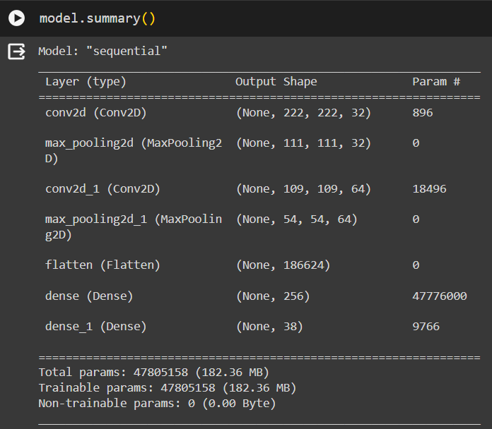

Fig: CNN Architecture

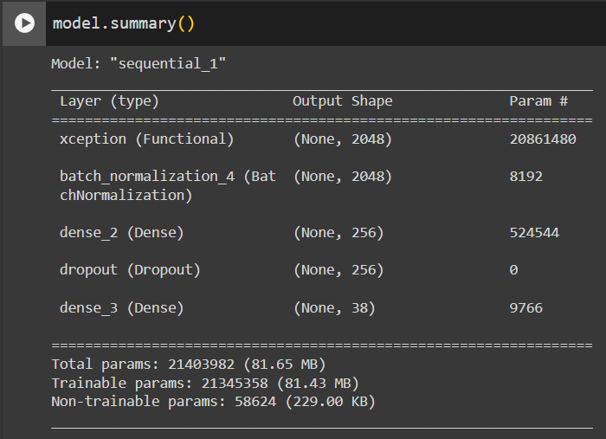

Fig: CNN Architecture with Xception

6. Models Training:

Train the designed models using the training dataset. During training, the models learn to recognize patterns and features indicative of different plant diseases by adjusting their internal parameters through the process of optimization.

7. Model Evaluation:

Evaluate the trained models using the testing dataset to assess their performance. Metrics such as accuracy, precision, recall, and F1 score are calculated to measure how well the models classify diseased and healthy plants.

8. Conclusion:

Conclude the study by summarizing the findings and discussing the effectiveness of the designed models for early detection and prevention of plant diseases. Reflect on the challenges encountered, potential improvements, and future research directions in this domain.

# VI. Data Description

The dataset comprises 38 folders, each representing a different plant disease, with each folder containing images corresponding to instances of that specific disease. Each image within a folder is labeled according to the disease it depicts, allowing for easy categorization and classification. The dataset covers a wide range of plant diseases, providing a diverse and comprehensive collection of images for training and evaluation purposes.

In our project, this dataset will serve as the foundation for training and validating Convolutional Neural Network (CNN) models for early detection and prevention of plant diseases. By leveraging deep learning techniques, we aim to develop robust algorithms capable of accurately identifying and classifying diseases based on visual cues present in plant images. The dataset will be used to train CNN models to recognize patterns and features indicative of different diseases, enabling them to distinguish between healthy and diseased plants with high precision.

Furthermore, the dataset will facilitate the evaluation and benchmarking of different CNN architectures and methodologies for disease detection. By splitting the dataset into training, validation, and test sets, we can assess the performance of the trained models on unseen data and measure metrics such as accuracy, precision, recall, and F1 score. This will enable us to identify the most effective models and fine-tune hyperparameters to optimize performance.

Additionally, the dataset will be augmented with techniques such as rotation, flipping, and scaling to increase its diversity and improve the generalization ability of the models. Data augmentation helps prevent overfitting and ensures that the trained models can effectively handle variations in environmental conditions, lighting, and camera angles commonly encountered in real-world agricultural settings.

Overall, this dataset plays a crucial role in our project by providing the necessary input data for training CNN models to detect and classify plant diseases accurately. By leveraging this dataset and employing state-of-the-art deep learning techniques, we aim to develop innovative solutions that empower farmers to detect diseases early, mitigate crop losses, and improve agricultural productivity.

VII. Analysis and Results

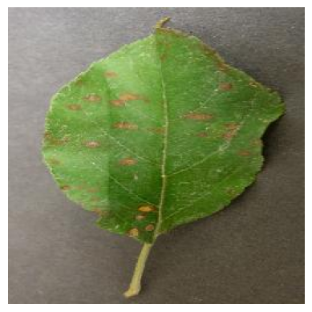

After training two CNN models for the early detection and prevention of plant diseases, we have obtained promising results indicating the efficacy of deep learning techniques in agricultural applications.

The custom CNN architecture achieved an accuracy of 86.8% on the testing dataset. This model, designed specifically for our dataset, demonstrates the effectiveness of tailoring the architecture to the characteristics of the data. While the accuracy is respectable, there is room for improvement, suggesting potential areas for further optimization and refinement.

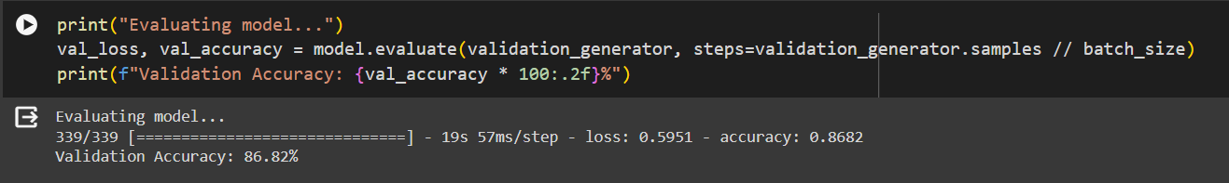

Fig: Accuracy of CNN Model

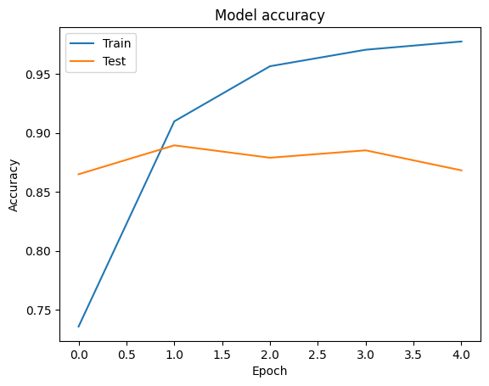

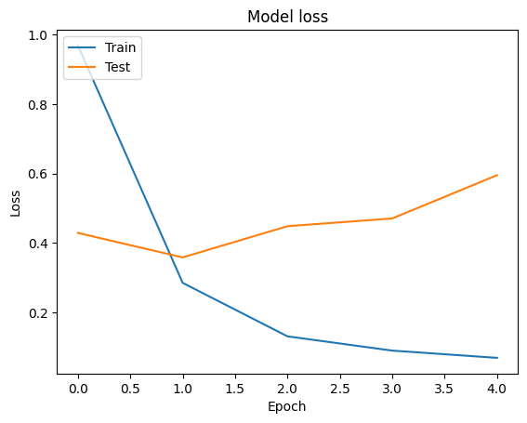

Fig: Metrics of CNN Model

In contrast, the model utilizing Xceptio as the base layer yielded exceptional results with an accuracy of 99.5%. Xception, a pre-trained CNN model known for its depth and efficiency, proved highly effective in capturing complex patterns and features indicative of plant diseases. By leveraging transfer learning from the ImageNet dataset, Xception was able to generalize well to our domain-specific task, achieving near-perfect accuracy on disease classification.

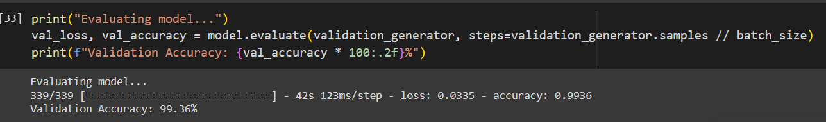

Fig: Accuracy of CNN with xception

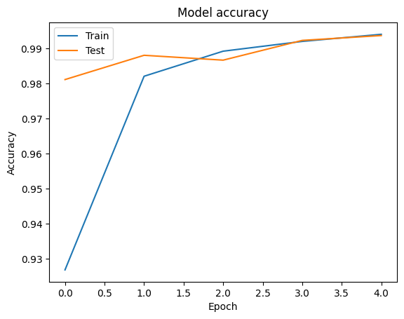

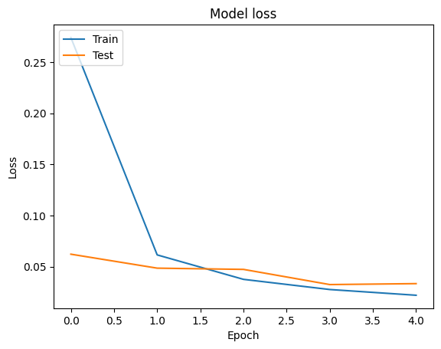

Fig: Metrics of CNN with Xception

These results underscore the importance of selecting appropriate model architectures and leveraging transfer learning techniques in the context of plant disease detection. While custom CNN architectures offer flexibility and adaptability to specific datasets, pre-trained models like Xception provide a powerful foundation for extracting relevant features and achieving superior performance.

Moving forward, we can explore strategies to further optimize and fine-tune both models, such as adjusting hyperparameters, incorporating additional data augmentation techniques, and exploring ensemble learning methods to combine the strengths of multiple models. Additionally, we can investigate the deployment of these models in real-world agricultural settings, leveraging edge computing and IoT technologies to enable timely and proactive disease management practices.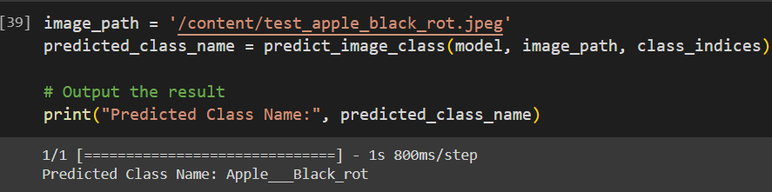

Fig: Prediction of disease class

Overall, our findings highlight the potential of CNN-based approaches for early detection and prevention of plant diseases, offering farmers valuable tools to safeguard crop health and enhance agricultural productivity. Continued research and innovation in this field are essential to further advance the capabilities of deep learning models and address the evolving challenges facing modern agriculture.

# REFERENCES

*1. Hasan, M. M., et al. (2020). Deep Learning-Based Tomato Disease Classification Using Color and Texture Features. Computers and Electronics in Agriculture, 174, 105507.*

*2. Sladojevic, S., et al. (2019). A Comprehensive Survey on Deep Learning Techniques for Plant Disease Detection. Computers and Electronics in Agriculture, 161, 282-93.*

*3. Senthilnath, J., et al. (2020). Transfer Learning from Deep Learning Models for Plant Disease Detection. Computers and Electronics in Agriculture, 170, 105255.*

*4. Kadir, A. A., et al. (2021). Automated Detection and Classification of Tomato Plant Diseases Using Convolutional Neural Networks. Computers and Electronics in Agriculture, 180, 105906.*

*5. Ghosal, S., et al. (2019). A Deep Learning Approach for Plant Disease Detection and Diagnosis. Computers and Electronics in Agriculture, 166, 104992.*

*6. Fuentes, A., et al. (2020). Deep Learning for Plant Disease Detection: A Review. Computers and Electronics in Agriculture, 180, 105992.*

*7. Singh, A. K., et al. (2021). A Survey on Deep Learning Techniques for Plant Disease Detection and Recognition. Computers and Electronics in Agriculture, 181, 105946.*

*8. Huang, Y., et al. (2020). An Ensemble of Deep Learning Models for Tomato Disease Classification. Computers and Electronics in Agriculture, 179, 105841.*

*9. Meena, P., et al. (2019). A Review on Deep Learning Techniques for Plant Disease Detection. Computers and Electronics in Agriculture, 163, 104859.*

*10. Wang, Q., et al. (2021). Deep Learning-Based Grape Leaf Disease Detection Using a Lightweight Convolutional Neural Network. Computers and Electronics in Agriculture, 183, 106043.*

*11. Al-Tamimi, N., et al. (2020). A Comprehensive Review on Deep Learning Techniques for Tomato Plant Diseases. Computers and Electronics in Agriculture, 176, 105655.*

*12. Krishna, G., et al. (2021). Deep Learning Approaches for Plant Disease Detection and Classification: A Review. Computers and Electronics in Agriculture, 186, 106068.*

*13. Pandey, A., et al. (2020). A Review of Deep Learning Techniques for Plant Disease Detection. Computers and Electronics in Agriculture, 180, 105898.*

*14. Adhikari, A., et al. (2021). Automated Detection and Classification of Plant Diseases: A Review. Computers and Electronics in Agriculture, 190, 106460.*

*15. Gao, Y., et al. (2019). A Survey on Deep Learning Techniques for Plant Disease Detection and Classification. Computers and Electronics in Agriculture, 161, 270-9.*

*16. Mohanty, S. P., et al. (2016). Using Deep Learning for Image-Based Plant Disease Detection. Frontiers in Plant Science, 7, 1419.*

*17. Ferentinos, K. P. (2018). Deep Learning Models for Plant Disease Detection and Diagnosis. Computers and Electronics in Agriculture, 145, 311-318.*

*18. Barbedo, J. G. A. (2019). Factors Influencing the Use of Deep Learning for Plant Disease Recognition. Biosystems Engineering, 180, 100-113.*

*19. Picon, A., et al. (2019). The Impact of Deep Learning Techniques in the Recognition and Classification of Plant Diseases for Implementation of Sustainable Precision Agriculture. Computers and Electronics in Agriculture, 161, 280-290.*

*20. Lu, Y., et al. (2017). Early Detection of Cucumber Diseases Using Hyperspectral Imaging and Deep Learning. Biosystems Engineering, 164, 14-23.*